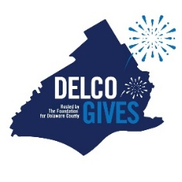

Delco Gives 2026 Canva Template Links & Usage Guide
Delco Gives 2026 takes place on May 6-7, 2026
Below are Canva template links to the official Delco Gives 2026 graphics that nonprofits can use to promote their participation across email, social media, and print.
All templates are pre-designed to align with Delco Gives branding. You can customize them by adding your own photos, logos, and messaging where indicated.

How to Use These Canva Templates
- Click the Canva link for the template you want to use.
- A Canva webpage will open.
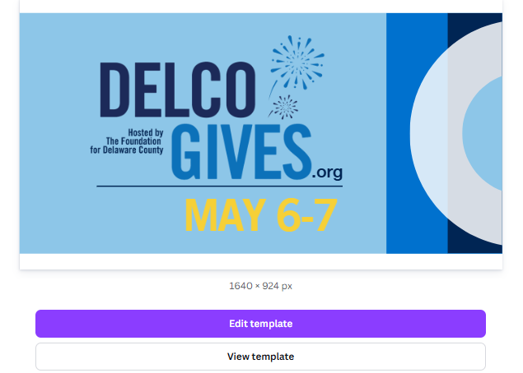
- Select “View Template”
  - This creates your own editable copy.
- Once the template opens, follow the notes included within the design to customize it.
- Download your final design and post.

Tip: Many templates include instructions in the Notes section at the bottom of the Canva design.
Review example below.
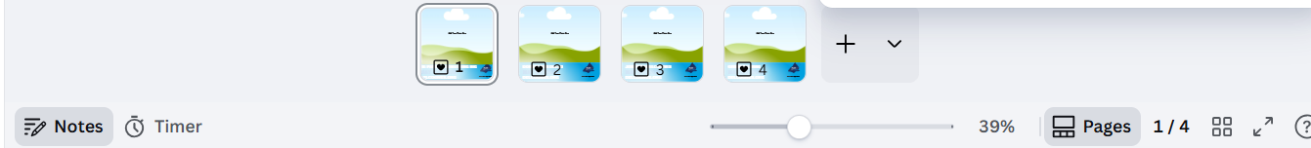
Canva Template Links Below
Delco Gives Logos
Delco Gives w/o county map
Delco Gives w county map

Email Signature. Compatible with Outlook, Gmail, and Yahoo
Email Signature Template #1

LinkedIn - Use these banners on your organization’s LinkedIn profile to promote Delco Gives
LinkedIn Header Template #1 and #2

Facebook - Designed for Facebook cover photos
Facebook Header #1 and #2
Facebook Header #3 with photos

Instagram Stories - Vertical designs for Instagram Stories. Some templates allow you to add your own photo or logo.
Be Part of Something Big
Give Back!
Instagram Story “Frame”
Instagram Story: What is Delco Gives

Square Social Media Posts (1:1 Format) - These posts work for Instagram and Facebook feeds
Delco Gives Frames (Choose from one of the 5 frames. Insert logo or photo)
Animated Instagram Post_- What is Delco Gives?
1:1 Social Frame
Countdown Graphics
Delco Gives: Save the Date (Instagram Post)
Social Media: Help us Help Others
Social Post: "Giving, It's a Delco Thing"
Social Post: Give Where You Live
Social Post: "I'm in for Delco Gives"
Social Post: "Protect Our Wooder"
Nonprofit DG Social Post: "Be Part of Something Big" - Add your own photo and logo
Social Post: "A Cause for Everyone"
Social Media: I Give For
Social Post: "Be Part of Something Big"
Social Post: "Show Some Love"
Social Post: "Donate For Delco"
Social Media: Help Me Support (Frame)

Print Materials - Multiple versions available for download and customization
Delco Gives Print Flyer 8.5x11_All Versions

Brand Do’s & Don’ts
Do:
- Add your organization’s logo where indicated
- Replace photo placeholders with your own images
- Keep Delco Gives logos visible and unchanged
- Use approved messaging from this toolkit
Don’t:
- Change official Delco Gives colors or logos
- Stretch or distort graphics
- Remove sponsor or brand marks

Posting Tips
- Instagram feed posts: download PNG for best quality
- Stories/Reels: use vertical templates (1080x1920)
- Leave space around edges so text isn’t cut off
- Add alt text to images for accessibility

Need Help?
If you have questions about using the templates or need support with accessing Canva, please contact the Delco Gives team

Additional Resources
Messaging Guide
Provides approved messaging, key themes, and language to help you promote Delco Gives consistently and effectively.
.
Delco Gives Messaging Guide and Toolkit - Nonprofits

THANK YOU for participating in Delco Gives! If you have ANY questions, do not hesitate to reach out to Bilal Taylor, btaylor@delcofoundation.org.

We encourage you to share posts across Facebook, LinkedIn, and Instagram.

Additional social captions by social media channels can be found here with instructions.

SAVE THE DATE/ PRE-GIVING
I am excited to announce that our nonprofit is participating in Delco Gives in 2026. On May 6-7, thousands of community members will come together to donate millions of dollars to hundreds of nonprofits in Delaware County. Let’s unite as one Delco!
Learn more➡️delcogives.org
#givewhereyoulive #delcogives #delco
___________________________________________________________________________________________

🎉🎉 Delco Gives Day is Almost Here! 🎉🎉
Mark your calendar: May 6-7
💙Support our nonprofit. Every donation helps our chances of winning cash prizes!
🌟 Give where you live. Make a difference in Delco!
➡ Learn more: delcogives.org
#DelcoGives #GiveLocalDelco #MakeADifference
___________________________________________________________________________________________
Join us for Delco Gives on May 6-7! This is your chance to support the causes that matter most, from arts and education, to protecting animals, and preserving our trails and environment. 🌿🎨🐾📚 There are so many worthy causes!
___________________________________________________________________________________________
Be part of Delco Gives! 24 hours, hundreds of nonprofits! Learn more at delcogives.org. #DelcoGives
___________________________________________________________________________________________
Aston, Upper Darby, Media, Clifton Heights... There are dozens of townships and boroughs, but we are all ONE Delco!
Together, in one day, you can support us, along with hundreds of our community’s nonprofits. Donate for Delco on May 6-7.
Learn more ➡️delcogives.org,
#DelcoGives
___________________________________________________________________________________________
No one shows heart like Delco does – it's in the wooder! On May 6-7, you can support our nonprofit and hundreds of others at delcogives.org. $10 can make a difference. Choose your favorite cause or discover new ones. Be part of something BIG! #DelcoGives
___________________________________________________________________________________________
On May 6-7, let's come together to create a brighter future for Delaware County. 24-hours, hundreds of local nonprofits = a lasting impact on the community. Mark your calendars and get ready to give to Delco! #DelcoGives
_____________________________________________________________________________________________
Delco is coming together for a county-wide 24-hour day of giving. From May 6-7, donate online! Your donation, no matter the size, will have a lasting impact on our community. You don't need a lot of dollars, just a lot of heart! Give your heart out, May 6-7, Delco!! Visit delcogives.org to learn more. #DelcoGives
___________________________________________________________________________________________
One week until Delco Gives! Join us for Delco Gives on May 6-7. 24 hours of giving + Hundreds of nonprofits! Together, we can make real change happen in our community. Please help us spread the word: delcogives.org, and don't forget to donate!
You don't need a lot of dollars, just a lot of heart! #DelcoGives
___________________________________________________________________________________________
🎉 Delco Gives is Almost Here! 🎉
🗓 Mark your calendar: May 6-7
💙 Support us as we provide critical services, and increase our chances of 🏆 Winning cash prizes
🌟 Give where you live. Make a difference in Delco!
➡️ Learn more: delcogives.org
#DelcoGives #GiveLocalDelco #MakeADifference

☝️One week until Delco Gives! One Day - Hundreds of nonprofits!
Join me on May 6 - 7.
How can you help?
1️⃣Spread the word. Tell your friends and family to make a plan to donate.
2️⃣Donate on May 6-7! You only need $10 and it only takes 10 minutes.
3️⃣Volunteer or attend one of the in-person Delco Gives events.
Together, we can make real change happen Learn more ➡️delcogives.org,
#DelcoGives

GIVING
DELCO GIVES IS HERE! Donate at delcogives.org. Support our nonprofit! Give where you live. #GivelocalDelco #DelcoGives

🌟 DELCO GIVES IS HERE! 🌟
💙 Each nonprofit receives extra money based on how many donors they have, not how much each donor gives. So grab a few friends and support us!
✅ Donate now: delcogives.org
🏡 Give where you live. Make a difference in Delco!
#GivelocalDelco #DelcoGives
___________________________________________________________________________________
💵 $10 + 10 Minutes = 10,000 Ways to Impact Delco!
✨ Be part of the collective good transforming Delaware County.
🌟 It’s quick. It’s easy. It makes a BIG difference.
➡️ Donate now: delcogives.org
By Delco, for Delco 💙
#DelcoGives #GiveLocalDelco #ImpactDelco
__________________________________________________________________________________
There are so many worthy causes in so many corners of Delco. Today, as one Delco, we’re uniting on one platform to support hundreds of local nonprofits. Visit delcogives.org today and give as little as $10 to donate for Delco. #DelcoGives
__________________________________________________________________________________

Last year, our community helped us raise $1.7 million for the nonprofit sector. Can you help us get to $2 million? Small gifts make a difference!

Learn more: delcogives.org
__________________________________________________________________________________
Did you love xxx? We rely on generous community donations to operate. Help ensure our future by making a donation on Delco Gives! Every donation will receive bonus dollars to match!
POST- GIVING/THANK YOU!
❤️We are so very thankful to everyone who donated this Delco Gives! Together we raised $____!! You are making a difference in Delco

🎉 Thank You, Delco! 🎉
💙 Your incredible generosity will make a lasting impact across our community.
✨ Together, we raised an amazing $_______
🌟 Thank you for supporting Delco Gives and making a difference. This is the power of giving where you live.
#DelcoGives #delco

HASHTAGS
#DelcoGives #delco

